Selection: 1

| Please choose a lesson, or type 0 to return to course menu.

1: Introduction 2: Probability1 3: Probability2

4: ConditionalProbability 5: Expectations 6: Variance

7: CommonDistros 8: Asymptotics 9: T Confidence Intervals

10: Hypothesis Testing 11: P Values 12: Power

13: Multiple Testing 14: Resampling

Selection: 8

| Attempting to load lesson dependencies...

| Package ‘ggplot2’ loaded correctly!

| | | 0%

| Asymptotics. (Slides for this and other Data Science courses may be found at github

| https://github.com/DataScienceSpecialization/courses/. If you care to use them, they must

| be downloaded as a zip file and viewed locally. This lesson corresponds to

| 07_Statistical_Inference/07_Asymptopia.)

...

| |= | 1%

| In this lesson, we'll discuss asymptotics, a topic which describes how statistics behave

| as sample sizes get very large and approach infinity. Pretending sample sizes and

| populations are infinite is useful for making statistical inferences and approximations

| since it often leads to a nice understanding of procedures.

...

| |== | 3%

| Asymptotics generally give no assurances about finite sample performance, but they form

| the basis for frequency interpretation of probabilities (the long run proportion of times

| an event occurs).

...

| |=== | 4%

| Recall our simulations and discussions of sample means in previous lessons. We can now

| talk about the distribution of sample means of a collection of iid observations. The mean

| of the sample mean estimates what?

1: population mean

2: sigma^2/n

3: population variance

4: standard error

Selection: 1

| You got it right!

| |==== | 5%

| The Law of Large Numbers (LLN) says that the average (mean) approaches what it's

| estimating. We saw in our simulations that the larger the sample size the better the

| estimation. As we flip a fair coin over and over, it eventually converges to the true

| probability of a head (.5).

...

| |====== | 7%

| The LLN forms the basis of frequency style thinking.

...

| |======= | 8%

| To see this in action, we've copied some code from the slides and created the function

| coinPlot. It takes an integer n which is the number of coin tosses that will be

| simulated. As coinPlot does these coin flips it computes the cumulative sum (assuming

| heads are 1 and tails 0), but after each toss it divides the cumulative sum by the number

| of flips performed so far. It then plots this value for each of the k=1...n tosses. Try

| it now for n=10.

> coinPlot(10)

| Nice work!

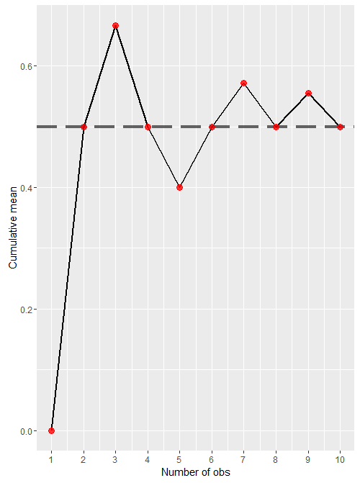

| |======== | 10%

| Your output depends on R's random number generator, but your plot probably jumps around a

| bit and, by the 10th flip, your cumulative sum/10 is probably different from mine. If you

| did this several times, your plots would vary quite a bit. Now call coinPlot again, this

| time with 10000 as the argument.

> coinPlot(10000)

| All that hard work is paying off!

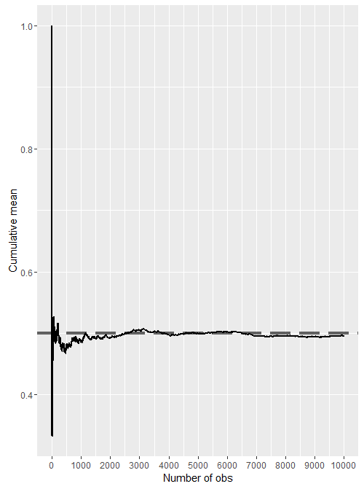 | |========= | 11%

| See the difference? Asymptotics in Action! The line approaches its asymptote of .5. This

| is the probability you expect since what we're plotting, the cumulative sum/number of

| flips, represents the probability of the coin landing on heads. As we know, this is .5 .

...

| |========== | 12%

| We say that an estimator is CONSISTENT if it converges to what it's trying to estimate.

| The LLN says that the sample mean of iid samples is consistent for the population mean.

| This is good, right?

...

| |=========== | 14%

| Based on our previous lesson do you think the sample variance (and hence sample

| deviation) are consistent as well?

1: No

2: Yes

Selection: 2

| You are really on a roll!

| |============ | 15%

| Now for something really important - the CENTRAL LIMIT THEOREM (CLT) - one of the most

| important theorems in all of statistics. It states that the distribution of averages of

| iid variables (properly normalized) becomes that of a standard normal as the sample size

| increases.

...

| |============= | 16%

| Let's dissect this to see what it means. First, 'properly normalized' means that you

| transformed the sample mean X'. You subtracted the population mean mu from it and divided

| the difference by sigma/sqrt(n). Here sigma is the standard deviation of the population

| and n is the sample size.

...

| |=============== | 18%

| Second, the CLT says that for large n, this normalized variable, (X'-mu)/(sigma/sqrt(n))

| is almost normally distributed with mean 0 and variance 1. Remember that n must be large

| for the CLT to apply.

...

| |================ | 19%

| Do you recognize sigma/sqrt(n) from our lesson on variance? Since the population std

| deviation sigma is unknown, sigma/sqrt(n) is often approximated by what?

1: the mean of the population

2: the variance of the population

3: I give up

4: the standard error of the sample mean

Selection: 4

| Keep working like that and you'll get there!

| |================= | 21%

| Let's rephrase the CLT. Suppose X_1, X_2, ... X_n are independent, identically

| distributed random variables from an infinite population with mean mu and variance

| sigma^2. Then if n is large, the mean of the X's, call it X', is approximately normal

| with mean mu and variance sigma^2/n. We denote this as X'~N(mu,sigma^2/n).

... 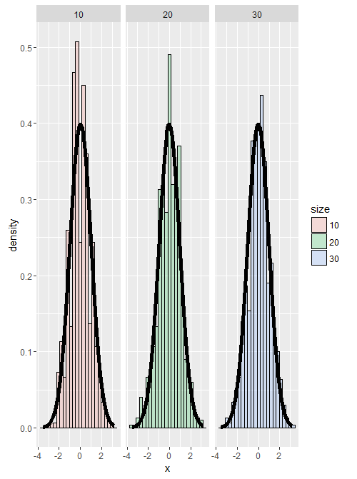

| |================== | 22%

| To show the CLT in action consider this figure from the slides. It presents 3 histograms

| of 1000 averages of dice rolls with sample sizes of 10, 20 and 30 respectively. Each

| average of n dice rolls (n=10,20,30) has been normalized by subtracting off the mean

| (3.5) then dividing by the standard error, sqrt(2.92/n). The normalization has made each

| histogram look like a standard normal, i.e., mean 0 and standard deviation 1.

...

| |=================== | 23%

| Notice that the CLT said nothing about the original population being normally

| distributed. That's precisely where its usefulness lies! We can assume normality of a

| sample mean no matter what kind of population we have, as long as our sample size is

| large enough and our samples are independent. Let's look at how it works with a binomial

| experiment like flipping a coin.

...

| |==================== | 25%

| Recall that if the probability of a head (call it 1) is p, then the probability of a tail

| (0) is 1-p. The expected value then is p and the variance is p-p^2 or p(1-p). Suppose we

| do n coin flips and let p' represent the average of these n flips. We normalize p' by

| subtracting the mean p and dividing by the std deviation sqrt(p(1-p)/n). Let's do this

| for 1000 trials and plot the resulting histogram.

... 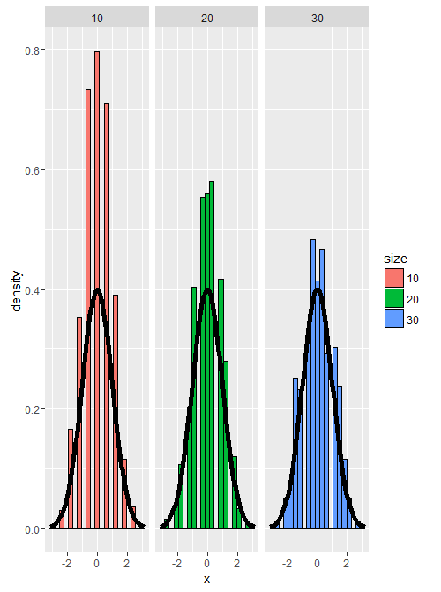

| |===================== | 26%

| Here's a figure from the slides showing the results of 3 such trials where each trial is

| for a different value of n (10, 20, and 30) and the coin is fair,so E(X)=.5 and the

| standard error is 1/(2sqrt(n)). Notice how with larger n (30) the histogram tightens up

| around the mean 0.

...

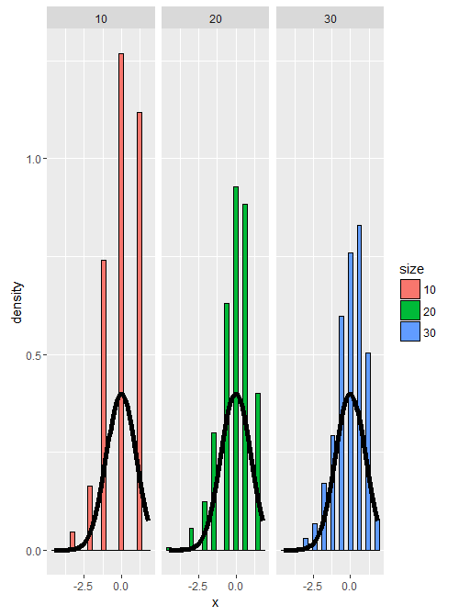 | |====================== | 27%

| Here's another plot from the slides of the same experiment, this time using a biassed

| coin. We set the probability of a head to .9, so E(X)=.9 and the standard error is

| sqrt(.09/n) Again, the larger the sample size the more closely the distribution looks

| normal, although with this biassed coin the normal approximation isn't as good as it was

| with the fair coin.

...

| |======================== | 29%

| Now let's talk about confidence intervals.

... 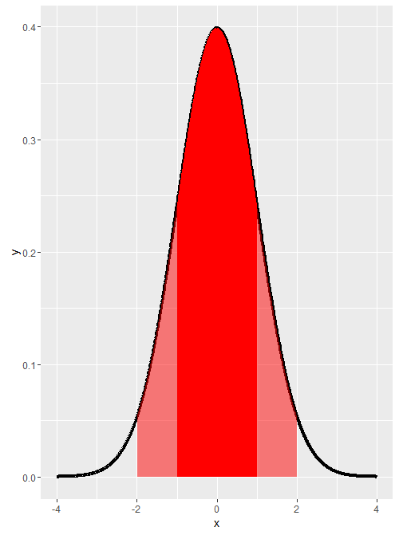

| |========================= | 30%

| We know from the CLT that for large n, the sample mean is normal with mean mu and

| standard deviation sigma/sqrt(n). We also know that 95% of the area under a normal curve

| is within two standard deviations of the mean. This figure, a standard normal with mu=0

| and sigma=1, illustrates this point; the entire shaded portion depicts the area within 2

| standard deviations of the mean and the darker portion shows the 68% of the area within 1

| standard deviation.

...

| |========================== | 32%

| It follows that 5% of the area under the curve is not shaded. By symmetry of the curve,

| only 2.5% of the data is greater than the mean + 2 standard deviations

| (mu+2*sigma/sqrt(n)) and only 2.5% is less than the mean - 2 standard deviations

| (mu-2*sigma/sqrt(n)).

...

| |=========================== | 33%

| So the probability that the sample mean X' is bigger than mu + 2sigma/sqrt(n) OR smaller

| than mu-2sigma/sqrt(n) is 5%. Equivalently, the probability of being between these

| limits is 95%. Of course we could have different sizes of intervals. If we wanted

| something other than 95, then we would use a quantile other than 2.

...

| |============================ | 34%

| The quantity X' plus or minus 2 sigma/sqrt(n) is called a 95% interval for mu. The 95%

| says that if one were to repeatedly get samples of size n, about 95% of the intervals

| obtained would contain mu, the quantity we're trying to estimate.

...

| |============================= | 36%

| Note that for a 95% confidence interval we divide (100-95) by 2 (since we have both left

| and right tails) and add the result to 95 to compute the quantile we need. The 97.5

| quantile is actually 1.96, but for simplicity it's often just rounded up to 2. If you

| wanted to find a 90% confidence interval what quantile would you want?

1: 85

2: 95

3: 90

4: 100

Selection: 2

| That's a job well done!

| |============================== | 37%

| Use the R function qnorm to find the 95th quantile for a standard normal distribution.

| Remember that qnorm takes a probability as an input. You can use default values for all

| the other arguments.

> qnorm(.95)

[1] 1.644854

| You got it right!

| |=============================== | 38%

| As we've seen before, in a binomial distribution in which p represents the probability or

| proportion of success, the variance sigma^2 is p(1-p), so the standard error of the

| sample mean p' is sqrt(p(1-p)/n) where n is the sample size. The 95% confidence interval

| of p is then p' +/- 2*sqrt(p(1-p)/n). The 2 in this formula represents what?

1: the variance of p'

2: the approximate 97.5% normal quantile

3: the standard error of p'

4: the mean of p'

Selection: 2

| You got it!

| |================================= | 40%

| A critical point here is that we don't know the true value of p; that's what we're trying

| to estimate. How can we compute a confidence interval if we don't know p(1-p)? We could

| be conservative and try to maximize it so we get the largest possible confidence

| interval. Calculus tells us that p(1-p) is maximized when p=1/2, so we get the biggest

| 95% confidence interval when we set p=1/2 in the formula p'+/- 2*sqrt(p(1-p)/n).

...

| |================================== | 41%

| Using 1/2 for the value of p in the formula above yields what expression for the 95%

| confidence interval for p?

1: p'+/- 1/(2*sqrt(n))

2: p'+/- 1/sqrt(n)

3: p'+/- 2*sqrt(n)

Selection: 2

| You are doing so well!

| |=================================== | 42%

| Here's another example of applying this formula from the slides. Suppose you were running

| for office and your pollster polled 100 people. Of these 60 claimed they were going to

| vote for you. You'd like to estimate the true proportion of people who will vote for you

| and you want to be 95% confident of your estimate. We need to find the limits that will

| contain the true proportion of your supporters with 95% confidence, so we'll use the

| formula p' +/- 1/sqrt(n) to answer this question. First, what value would you use for p',

| the sampled estimate?

1: .60

2: 1.00

3: .56

4: .10

Selection: 1

| Excellent work!

| |==================================== | 44%

| What would you use for 1/sqrt(n)?

1: 1/100

2: 1/sqrt(60)

3: 1/sqrt(56)

4: 1/10

Selection: 4

| Keep working like that and you'll get there!

| |===================================== | 45%

| The bounds of the interval then are what?

1: .55 and .65

2: .46 and .66

3: I haven't a clue

4: .5 and .7

Selection: 4

| Your dedication is inspiring!

| |====================================== | 47%

| How do you feel about the election?

1: I'll pull out

2: confident

3: Perseverance, that's the answer

4: unsure

Selection: 2

| You nailed it! Good job!

| |======================================= | 48%

| Another technique for calculating confidence intervals for binomial distributions is to

| replace p with p'. This is called the Wald confidence interval. We can also use the R

| function qnorm to get a more precise quantile value (closer to 1.96) instead of our

| ballpark estimate of 2.

...

| |======================================== | 49%

| With the formula p'+/- qnorm(.975)*sqrt(p'(1-p')/100), use the p' and n values from above

| and the R construct p'+c(-1,1)... to handle the plus/minus portion of the formula. You

| should see bounds similar to the ones you just estimated.

> .6 + c(-1,1)*qnorm(.975)*sqrt(.6*.4/100)

[1] 0.5039818 0.6960182

| You are amazing!

| |========================================== | 51%

| As an alternative to this Wald interval, we can also use the R function binom.test with

| the parameters 60 and 100 and let all the others default. This function "performs an

| exact test of a simple null hypothesis about the probability of success in a Bernoulli

| experiment." (This means it guarantees the coverages, uses a lot of computation and

| doesn't rely on the CLT.) This function returns a lot of information but all we want now

| are the values of the confidence interval that it returns. Use the R construct x$conf.int

| to find these now.

> binom.test(60,100)$conf.int

[1] 0.4972092 0.6967052

attr(,"conf.level")

[1] 0.95

| You are doing so well!

| |=========================================== | 52%

| Close to what we've seen before, right? Now we're going to see that the Wald interval

| isn't very accurate when n is small. We'll use the example from the slides.

...

| |============================================ | 53%

| Suppose we flip a coin a small number of times, say 20. Also suppose we have a function

| mywald which takes a probability p, and generates 30 sets of 20 coin flips using that

| probability p. It uses the sampled proportion of success, p', for those 20 coin flips to

| compute the upper and lower bounds of the 95% Wald interval, that is, it computes the two

| numbers p'+/- qnorm(.975) * sqrt(p' * (1-p') / n) for each of the 30 trials. For the

| given true probability p, we count the number of times out of those 30 trials that the

| true probability p was in the Wald confidence interval. We'll call this the coverage.

...

| |============================================= | 55%

| To make sure you understand what's going on, try running mywald now with the probability

| .2. It will print out 30 p' values (which you don't really need to see), followed by 30

| lower bounds, 30 upper bounds and lastly the percentage of times that the input .2 was

| between the two bounds. See if you agree with the percentage you get. Usually it suffices

| to just count the number of times (out of the 30) that .2 is less than the upper bound.

> mywald(.2)

[1] "Here are the p' values"

[1] 0.35 0.25 0.10 0.25 0.10 0.20 0.30 0.15 0.25 0.05 0.10 0.35 0.15 0.15 0.30 0.30 0.25

[18] 0.20 0.20 0.25 0.15 0.25 0.05 0.20 0.20 0.10 0.30 0.35 0.05 0.25

[1] "Here are the lower"

[1] 0.140962697 0.060227303 -0.031478381 0.060227303 -0.031478381 0.024695492

[7] 0.099163455 -0.006490575 0.060227303 -0.045516829 -0.031478381 0.140962697

[13] -0.006490575 -0.006490575 0.099163455 0.099163455 0.060227303 0.024695492

[19] 0.024695492 0.060227303 -0.006490575 0.060227303 -0.045516829 0.024695492

[25] 0.024695492 -0.031478381 0.099163455 0.140962697 -0.045516829 0.060227303

[1] "Here are the upper"

[1] 0.5590373 0.4397727 0.2314784 0.4397727 0.2314784 0.3753045 0.5008365 0.3064906

[9] 0.4397727 0.1455168 0.2314784 0.5590373 0.3064906 0.3064906 0.5008365 0.5008365

[17] 0.4397727 0.3753045 0.3753045 0.4397727 0.3064906 0.4397727 0.1455168 0.3753045

[25] 0.3753045 0.2314784 0.5008365 0.5590373 0.1455168 0.4397727

[1] 0.9

| You got it!

| |============================================== | 56%

| Now that you understand the underlying principle, suppose instead of 30 trials, we used

| 1000 trials. Also suppose we did this experiment for a series of probabilities, say from

| .1 to .9 taking steps of size .05. More specifically, we'll call our function using 17

| different probabilities, namely .1, .15, .2, .25, ... .9 . We can then plot the

| percentages of coverage for each of the probabilities.

... 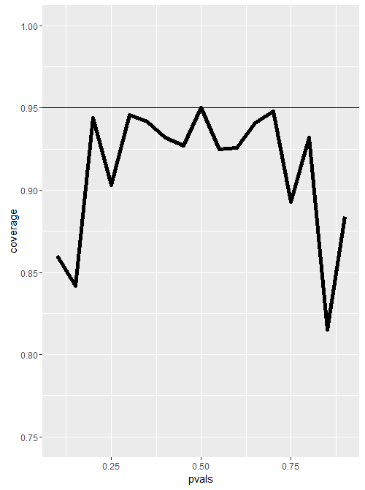

| |=============================================== | 58%

| Here's the plot of our results. Each of the 17 vertices show the percentage of coverage

| for a particular true probability p passed to the function. Results will vary, but

| usually the only probability that hits close to or above the 95% line is the p=.5 . So

| this shows that when n, the number of flips, is small (20) the CLT doesn't hold for many

| values of p, so the Wald interval doesn't work very well.

...

| |================================================ | 59%

| Let's try the same experiment and increase n, the number of coin flips in each of our

| 1000 trials, from 20 to 100 to see if the plot improves. Again, results may vary, but all

| the probabilities are much closer to the 95% line, so the CLT works better with a bigger

| value of n.

... 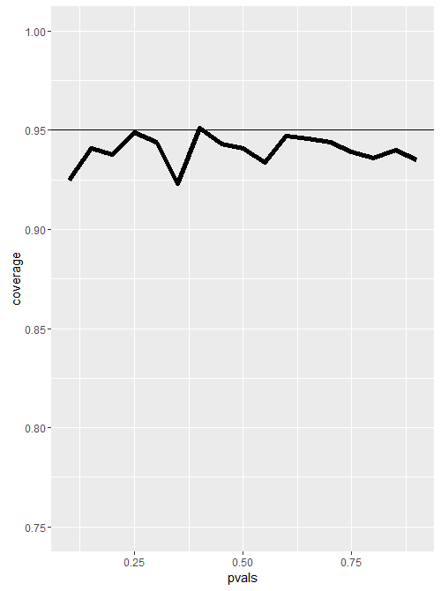

| |================================================= | 60%

| A quick fix to the problem of having a small n is to use the Agresti/Coull interval. This

| simply means we add 2 successes and 2 failures to the counts when calculating the

| proportion p'. Specifically, if X is the number of successes out of the 20 coin flips,

| then instead of setting p'=X/20, let p'=(X+2)/24. We use 24 as the number of trials since

| we've added 2 successes and 2 failures to the counts. Note that we still use 20 in the

| calculation of the upper and lower bounds.

... 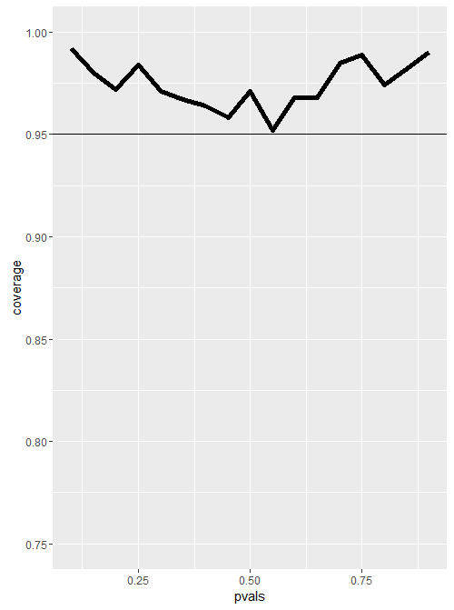

| |=================================================== | 62%

| Here's a plot using this Agresti/Coull interval, with 1000 trials of 20 coin flips each.

| It looks much better than both the original Wald with 20 coin flips and the improved Wald

| with 100 coin flips. However, this technique might make the confidence interval too wide.

...

| |==================================================== | 63%

| Why does this work? Adding 2 successes and 2 failures pulls p' closer to .5 which, as we

| saw, is the value which maximizes the confidence interval.

...

| |===================================================== | 64%

| To show this simply, we wrote a function ACCompar, which takes an integer input n. For

| each k from 1 to n it computes two fractions, k/n and (k+2)/(n+4). It then prints out the

| boolean vector of whether the new (k+2)/(n+4) fraction is less than the old k/n. It also

| prints out the total number of k's for which the condition is TRUE.

...

| |====================================================== | 66%

| For all k less than n/2, you see FALSE indicating that the new fraction is greater than

| or equal to k/n. For all k greater than n/2 you see TRUE indicating that the new fraction

| is less than the old. If k=n/2 the old and new fractions are equal.

...

| |======================================================= | 67%

| Try running ACCompar now with an input of 20.

> ACCompar(20)

[1] FALSE FALSE FALSE FALSE FALSE FALSE FALSE FALSE FALSE FALSE TRUE TRUE TRUE TRUE

[15] TRUE TRUE TRUE TRUE TRUE TRUE

[1] 10

| That's a job well done!

| |======================================================== | 68%

| Let's move on to Poisson distributions and confidence intervals. Recall that Poisson

| distributions apply to counts or rates. For the latter, we write X~Poisson(lambda*t)

| where lambda is the expected count per unit of time and t is the total monitoring time.

...

| |========================================================= | 70%

| Here's another example from the slides. Suppose a nuclear pump failed 5 times out of

| 94.32 days and we want a 95% confidence interval for the failure rate per day. The number

| of failures X is Poisson distributed with parameter (lambda*t). We don't observe the

| failure rate, but we estimate it as x/t. Call our estimate lambda_hat, so lambda_hat=x/t.

| According to theory, the variance of our estimated failure rate is lambda/t. Again, we

| don't observe lamdba, so we use our estimate of it instead. We thus approximate the

| variance of lambda_hat as lambda_hat/t.

...

| |========================================================== | 71%

| In this example what would you use as the estimated mean x/t?

1: I haven't a clue

2: 94.32/5

3: 5/94.32

Selection: 3

| That's the answer I was looking for.

| |============================================================ | 73%

| Set a variable lamb now with this value.

> lamb <- 5/94.32

| Excellent job!

| |============================================================= | 74%

| So lamb is our estimated mean and lamb/t is our estimated variance. The formula we've

| used to calculate a 95% confidence interval is est mean + c(-1,1)*qnorm(.975)*sqrt(est

| var). Use this formula now making the appropriate substitutions.

> lamb + c(-1,1)*qnorm(.975)*sqrt(lamb)

[1] -0.3982535 0.5042756

| You're close...I can feel it! Try it again. Or, type info() for more options.

| Type lamb +c(-1,1)*qnorm(.975)*sqrt(lamb/94.32) at the R prompt.

> lamb +c(-1,1)*qnorm(.975)*sqrt(lamb/94.32)

[1] 0.006545667 0.099476386

| You nailed it! Good job!

| |============================================================== | 75%

| As a check we can use R's function poisson.test with the arguments 5 and 94.32 to check

| this result. This is an exact test so it guarantees coverage. As with the binomial exact

| test, we only need to look at the conf portion of the result using the x$conf construct.

| Do this now.

> poisson.test(5, 94.32)

Exact Poisson test

data: 5 time base: 94.32

number of events = 5, time base = 94.32, p-value < 2.2e-16

alternative hypothesis: true event rate is not equal to 1

95 percent confidence interval:

0.01721254 0.12371005

sample estimates:

event rate

0.05301103

| You're close...I can feel it! Try it again. Or, type info() for more options.

| Type 'poisson.test(5,94.32)$conf' at the command prompt.

> 'poisson.test(5,94.32)$conf'

[1] "poisson.test(5,94.32)$conf"

| Try again. Getting it right on the first try is boring anyway! Or, type info() for more

| options.

| Type 'poisson.test(5,94.32)$conf' at the command prompt.

> poisson.test(5,94.32)$conf

[1] 0.01721254 0.12371005

attr(,"conf.level")

[1] 0.95

| That's correct!

| |=============================================================== | 77%

| Pretty close, right? Now to check the coverage of our estimate we'll run the same

| simulation experiment we ran before with binomial distributions. We'll vary our lambda

| values from .005 to .1 with steps of .01 (so we have 10 of them), and for each one we'll

| generate 1000 Poisson samples with mean lambda*t. We'll calculate sample means and use

| them to compute 95% confidence intervals. We'll then count how often out of the 1000

| simulations the true mean (our lambda) was contained in the computed interval.

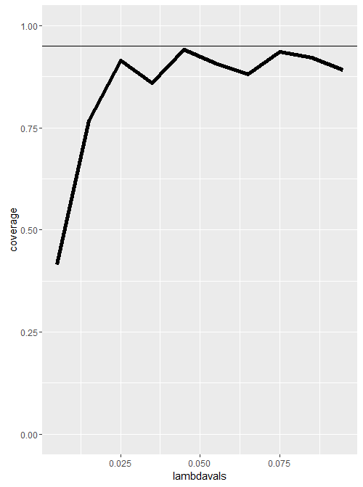

...

| |================================================================ | 78%

| Here's a plot of the results. We see that the coverage improves as lambda gets larger,

| and it's quite off for small lambda values.

...

| |================================================================= | 79%

| Now it's interesting to see how the coverage improves when we increase the unit of time.

| In the previous plot we used t=100 (rounding the 94.32 up). Here's a plot of the same

| experiment setting t=1000. We see that the coverage is much better for almost all the

| values of lambda, except for the smallest ones.

...

| |================================================================== | 81%

| Now for a quick review!

...

| |=================================================================== | 82%

| What tells us that averages of iid samples converge to the population means that they are

| estimating?

1: the law of small numbers

2: the law of large numbers

3: the BLT

4: the CLT

Selection: 4

| Try again. Getting it right on the first try is boring anyway!

| Think Big!

1: the CLT

2: the BLT

3: the law of small numbers

4: the law of large numbers

Selection: 3

| Try again. Getting it right on the first try is boring anyway!

| Think Big!

1: the law of large numbers

2: the CLT

3: the law of small numbers

4: the BLT

Selection: 1

| Great job!

| |===================================================================== | 84%

| What tells us that averages are approximately normal for large enough sample sizes

1: the law of large numbers

2: the BLT

3: the CLT

4: the law of small numbers

Selection: 3

| Perseverance, that's the answer.

| |====================================================================== | 85%

| The Central Limit Theorem (CLT) tells us that averages have what kind of distributions?

1: abnormal

2: Poisson

3: binomial

4: normal

Selection: 4

| You are really on a roll!

| |======================================================================= | 86%

| The Central Limit Theorem (CLT) tells us that averages have normal distributions centered

| at what?

1: the population variance

2: the population mean

3: the standard error

Selection: 2

| You're the best!

| |======================================================================== | 88%

| The Central Limit Theorem (CLT) tells us that averages have normal distributions with

| standard deviations equal to what?

1: the population mean

2: the standard error

3: the population variance

Selection: 2

| Nice work!

| |========================================================================= | 89%

| True or False - The Central Limit Theorem (CLT) tells us that averages always have normal

| distributions no matter how big the sample size

1: False

2: True

Selection: 1

| Excellent work!

| |========================================================================== | 90%

| To calculate a confidence interval for a mean you take the sample mean and add and

| subtract the relevant normal quantile times the what?

1: standard error

2: variance/n

3: variance

4: mean

Selection: 1

| You got it!

| |=========================================================================== | 92%

| For a 95% confidence interval approximately how many standard errors would you add and

| subtract from the sample mean?

1: 6

2: 8

3: 4

4: 2

Selection: 2

| Try again. Getting it right on the first try is boring anyway!

| Anything above 3 is pretty far from the mean. Also, purists would prefer 1.96 for this.

1: 8

2: 4

3: 6

4: 2

Selection: 4

| You are doing so well!

| |============================================================================ | 93%

| If you wanted increased coverage what would you do to your confidence interval?

1: decrease it

2: increase it

3: keep it the same

Selection: 2

| Excellent job!

| |============================================================================== | 95%

| If you had less variability in your data would your confidence interval get bigger or

| smaller?

1: smaller

2: bigger

Selection: 1

| You are doing so well!

| |=============================================================================== | 96%

| If you had larger sample size would your confidence interval get bigger or smaller?

1: bigger

2: smaller

Selection: 2

| You are quite good my friend!

| |================================================================================ | 97%

| A quick fix for small sample size binomial calculations is what?

1: changing data seem dishonest

2: add 2 successes and 4 failures

3: add 2 successes and 2 failures

4: add 2 successes and subtract 2 failures

Selection: 3

| Great job!

| |================================================================================= | 99%

| Congrats! You've concluded this lesson on asymptotics. We hope you feel confident and are

| asymptomatic after going through it.

...

| |==================================================================================| 100%

| Would you like to receive credit for completing this course on Coursera.org?

1: Yes

2: No

Selection: 1

What is your email address? sweeyean@gmail.com

What is your assignment token? xMKI24xNe6ULZ1Ez

Grade submission succeeded!

| You are quite good my friend!

| You've reached the end of this lesson! Returning to the main menu...

| Please choose a course, or type 0 to exit swirl.

1: Statistical Inference

2: Take me to the swirl course repository!

Selection: